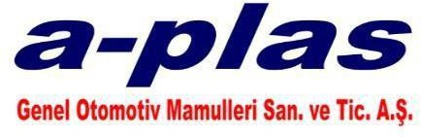

- ENVIRONMENTAL POLICY –

**A-PLAS GENEL OTOMOTİV MAMÜLLERİ SAN.TİC. A.Ş**. family,

We are environmentally conscious in our plastic component production for the automotive industry. As a business, we aim to leave a healthy and clean environment to our future generations, and to maintain and continuously improve our Environmental Management System in this direction.

In accordance with this purpose,

* To fulfill the legal and other obligations of Environmental Management.

 To carry out production activities taking into account the principles of Sustainable Environment and climate change,

 To ensure that the ecosystem and the environment are not harmed during our activities,

 To pay attention not to cause noise emissions from our company's transportation, transportation and industrial activities,

 Purchasing energy-efficient products, services, and technologies, supporting high-performance designs

 Considering energy efficient and environmentally friendly technologies while creating all processes from the design stage,

 In line with the goals and targets set each year, to reduce energy consumption and the amount of waste by using resources efficiently and supporting recycling in order to prevent environmental pollution,

 To use renewable energy sources in the near future,

 Within the framework of the established Environmental Management System, to cooperate with all our employees and to instill this awareness in them,

is one of our main goals.

**CHAIRMAN OF THE BOARD**

Ahmet AĞAOĞLU